Circular Dependency

Spring code:
User.java
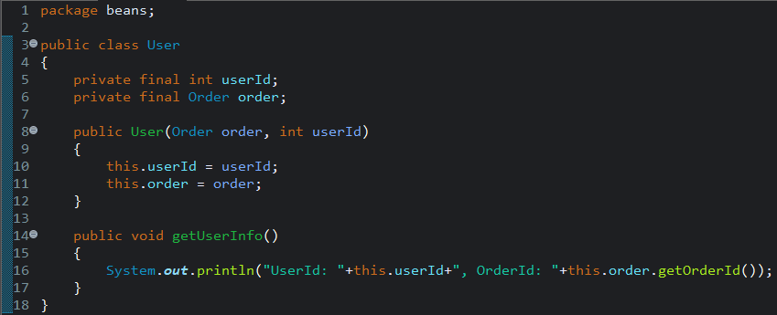
Order.java
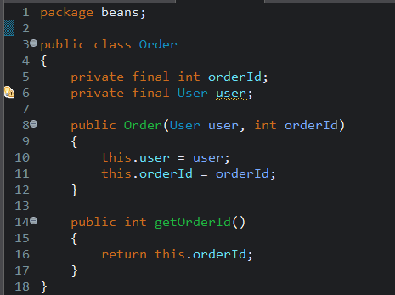

App.java
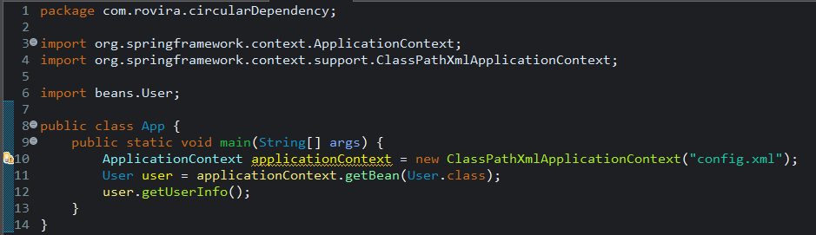
Config.xml
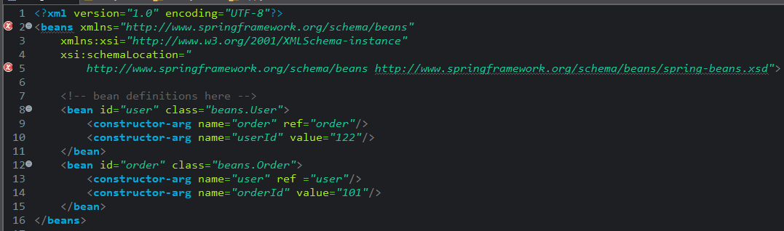
Output

Solution:
User.java
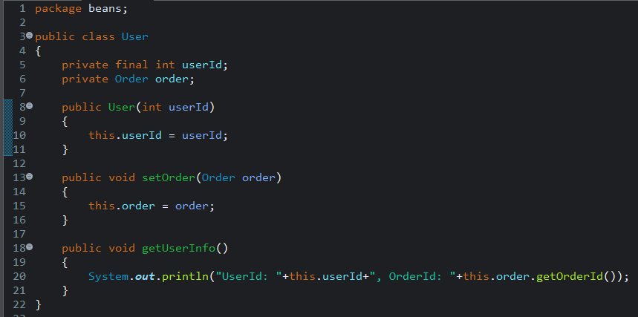

Order.java
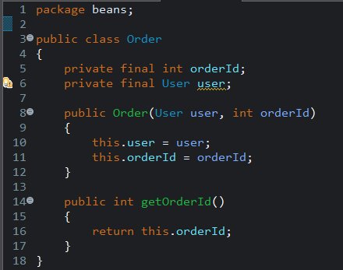

App.java
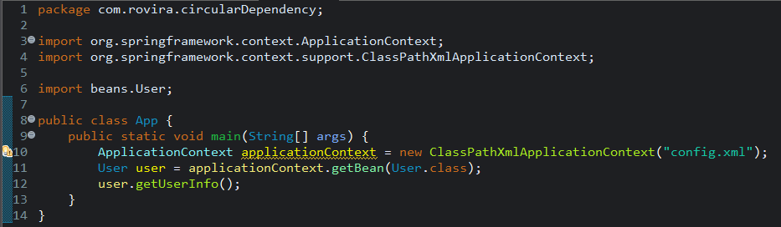
config.xml
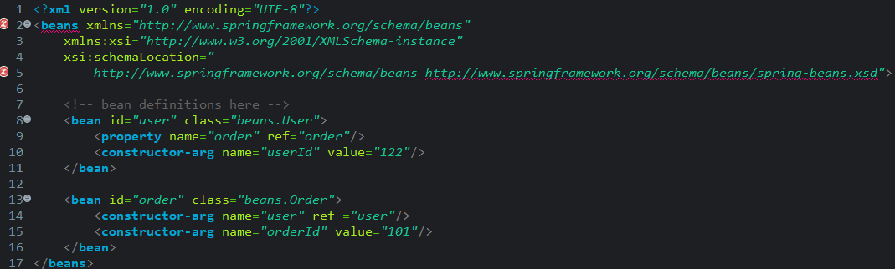
Output
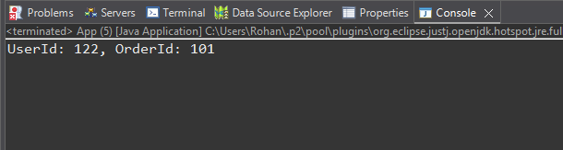
Problem:
Circular Dependency occurs because both User and Order depend on each other through constructor injection. Spring cannot create either object first, so bean creation fails with a BeanCurrentlyInCreationException.
Solution
Break the circular dependency by using setter injection for atleast one dependency (Order or User) instead of constructor injection. This allows Spring to create both beans first and inject the remaining dependency later, avoiding the circular dependency error.

